Review Comments
60% Civil Plan Review

Date: April 22, 2026
Responses: May 8, 2026 by JL and DW for Water & Sewer Related Items and by EW for Drainage Items ONLY.

Project: JWP Blvd Extension COF Project No: PZ-26-00050

Project Owner: City of Flagstaff COF Project Mgr: David Millis

Engineer: Peak Engineering
____________________________________________________________________

The City of Flagstaff has completed the first review of the 60% construction plans for the JWP Blvd Extension project. The plans have been returned for corrections as outlined below. Following are the items that must be addressed to obtain civil construction plan approval. The list below may not be an exhaustive list of deficiencies, particularly where required information was not provided. No partial acceptance is implied by the absence of comment. For re-submittal, please provide digital versions of the entire resubmittal, along with a written response to each comment to engineeringpermits@flagstaffaz.gov with copy to the DEPM below. If you have any questions, please contact David Millis, Development Engineer at (928)213-2681, david.millis@flagstaffaz.gov.
Substantive Engineering: Development Engineering, David Millis Approved with Conditions 04/22/2026
General --
Slope easements are not typically necessary on cut slopes uphill of ROW
Ensure that minimum 4’ is maintained from outside of water mains to lip of curb Confirmed, it is.
R1.5
Coordinate elevations with CDR Phase 2 plans. They are on NAVD27, we are on NAVD88. Coordinated match points.
Note 260 is showing streetlights in APS overhead transmission easement. Coordinate allowable height construction in this area
Water Sewer
General
Consider pulling hydrants from the 8”stubs to the future intersections rather than directly from the transmission main. This could replace some temp blowoffs. Changed pull location of hyddrants and eliminated blow offs.

Coordinate elevations with CDR. This may be a legacy of the datum/benchmark issue but elevation numbers are off by a few feet at the match point. Yes, correct.
W1.0
Add ARV at high point on 20” near cross Added.
W1.2
Show profiles of water line where running down the slope. Maximum bury depth to top of pipe is 6’ unless for short distances on vertical realignment or approval of the City Engineer. I’m not sure all of the constraints you are dealing with here but need to see if we can keep this shallower. Also note valves should not be located in any deep locations that might be approved. We recommend keeping it low to avoid SD crossing dips, additional ARVs and to provide proper cover for the valves. As discussed with Development Engineering and Water Services, okay to have deeper water main.
W1.5
Coordinate with CDR plan, they have a hydrant not very far from the end here and are showing an end of line valve. They also have a streetlight close to your proposed hydrant location. Confirm slope alignment of water main segments at connection. Coordinated hydrant location. Street light location still pending.
W2.0
Provide ARV at vertical realignment.
Discuss details of this alignment, depth and ROW/easement restrictions you are working within here. Depth and alignment requires additional approval Changed vertical design to push ARV to roadway slope where we can place the vent above the 100-yr flood elevation.
S1.0
Wood Patel is showing their outfall at 1.74 MGPD and entering with 15” pipe. The 12” at 0.2% slope will not carry this at 70% D/d/ Showing a 16” DIP sewer.
Show watertight manhole covers in the wash. Shown.
Show alignments of 12” line coming into the 42” and potential for aligning top of pipes. The 42” that we are connecting to is ~2’ BGS. We added detail showing the 16” pipe coming into the 42” pipe since the pipe crowns do not match given cover and slope constraints.
S2.0
The 42” pipe will need flotation calculations Pipe material was changed to RCP, lined. Flotation calculations provided, see memo.
Water services used a lined manhole rather than polymer concrete on Wildcat Interceptor. I assume it is cheaper, may consider that option. Yes, will work with Banicki to evaluate alternatives.
Show watertight manhole covers in wash. Shown.
Substantive Building & Safety: Building Safety, Brian Cook Approved 03/16/2026
No Comments
Substantive Current Planning: Current Planning, Alaxandra Pucciarelli Approved 03/23/2026
No Comments
Substantive Fire Prevention: Fire Prevention, Christopher Jack Approved with Conditions 03/25/2026
Fire hydrants shall be placed to alternate sides of the road. Development on Little America will be to the west only. Development on Elk Ridge is both sides we now show alternating sides.
Substantive Public Works: Public Works, Jarrett Nelson Approved with Conditions 04/02/2026
1. Note 610 Median Nose should reference COF Engineering Detail 10-06-015. The object marker sign should be per MUTCD OM-3R. Nose should transition to 2.5” curb per MAG detail 223 or less. Transition to 0” is preferred for snow plows
2. Pavement symbols material shall be ADOT Standard Specification 709 dual component epoxy per COF Code Chapter 13-16-006, please include material type in construction notes for clarity
3. Proposed guardrail end treatments (ADOT C10.23 SGET) are uncommon in the city. MSKT end treatments (ADOT C10.21) would be preferred as there are many similar end treatments already in the city
4. How is guardrail going to transition into the 38” single slope concrete bridge barrier? Please provide detail
Substantive Stormwater: Stormwater, Douglas Slover Approved with Conditions 04/06/2026
Douglas Slover, 2026-04-03, Civil Plan Review 60%
Approved with Conditions
Conditions of Approval
1. Beginning on R1.0 there are labels for Slope & Drainage Easement of varying widths. This should be labeled Slope Easement (SE).
2. Drainage Easements (DE) may be needed where ditches are used to convey runoff along roadway, outside of ROW.
3. Where a culvert or its inlet/outlet protection extends outside of ROW, provide a Drainage Easement (DE). DE to extend 8-feet beyond inlet/outlet or to end of required protection, whichever is greater.
4. In locations where sewer or water is near parallel to storm drain, provide minimum horizontal spacing or dimension. Ex, STA 202+50
SD is within 6’ at one locating, STA 229+50. Is this acceptable?
5. Storm drain, when running near parallel to roadway, should be located within roadway no closer than 4-feet from lip of gutter. See detail 9-01-010. If conflicts may make this problematic, design report should discuss limitations. A modification may be needed.
Please advise if located SD is in appropriate location. The line does encroach within 4’, this is to keep a 6’ clearance from WL and the gutter will be relocated in the future.
6. Where drainage has been collected and concentrated and thus outlets from ROW in a concentrated fashion, additional justification is needed for outlet protection to ensure erosion protection. Ex, STA 211+00.
Outlets have a designed riprap pad. Please see drainage report for details.
7. STA 236+50 there is an inlet headway in future roadway turnout. Provide label as to the nature of this inlet. IE, temporary or future extension, etc.
Inlet has been relocated and it is to collect offsite flow, please see drainage report.
8. Culvert crossing at STA 240+25 has inlet and outlet in graded slope. Final plans will need detail grading for this type of item.
Plans have been updated.
9. Easements should be shown on SD sheets.
Easements will be shown on the roadway plans.
10. Inlets along gutter line in bike lanes will need to ensure no protrusion further into bike lane than gutter section. Keep EOP and LIP of gutter line continuous at storm drain inlets.
Call catch basins will be curb inlet only.
11. On SD sheets, show MH cover location in relation to base. Per note 503 eccentric cones are used thus cover is not necessarily known. This should be compared against striping for best placement.
SDMH’s are shown where lid will be in correlation to the base.
12. Culvert crossings and storm drains that are excessively deep, i.e. greater than 10-feet of cover, may be required to be constructed of alternative material to provide added lifespan.
SD will be utilizes an ADS HP Storm that will be able to handle the deep stormdrains.
General Comments
1. Provide drainage report with subsequent plan submittal.
Report has been added to the submittal.
Substantive Traffic: Traffic, Stephanie Santana Return for Corrections 04/21/2026
- Transportation Engineering:
TYP – At all proposed intersections, do not provide median openings. Instead, install roll curb on both sides of the median and omit landscaping to allow fire trucks to traverse the median.
- TYP – At all proposed intersections, remove the ramps to cross JWP. We will plan for ramps when Elk Ridge develops and creates the median cuts.
- TYP - The catch basins shown encroach into the bike lane. Per COF Stormwater Management Manual, “Where possible, curb opening inlets should be used if the street has a bike lane”. Use a MAG Standard Detail, Curb Opening Catch Basin, rather than grates or combination inlets when located in a bike line. CDR & STL 405 used MAG 542-2 Type “I” along their portions of JWP.
- 5 of 44: Median Nose Transition – If required for this project, the following reflects our standard detail for zero-reveal medians. Where left turns are permitted from side streets, a parabolic curve should be incorporated.
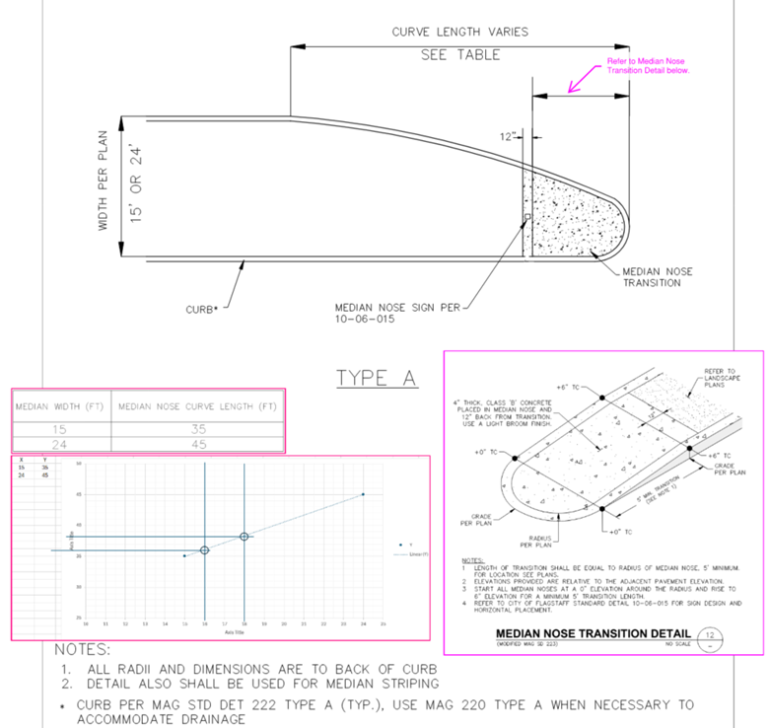
- 7 of 44: Adjust the streetlight at ~STA 204+25 (east side) a bit to the north to meet the spacing standard (200’ +10% = 220’ spacing max).
- 7 of 44: Ensure this project is coordinated with the STL405 plans. Below is a snip of the most recent STL405 set.
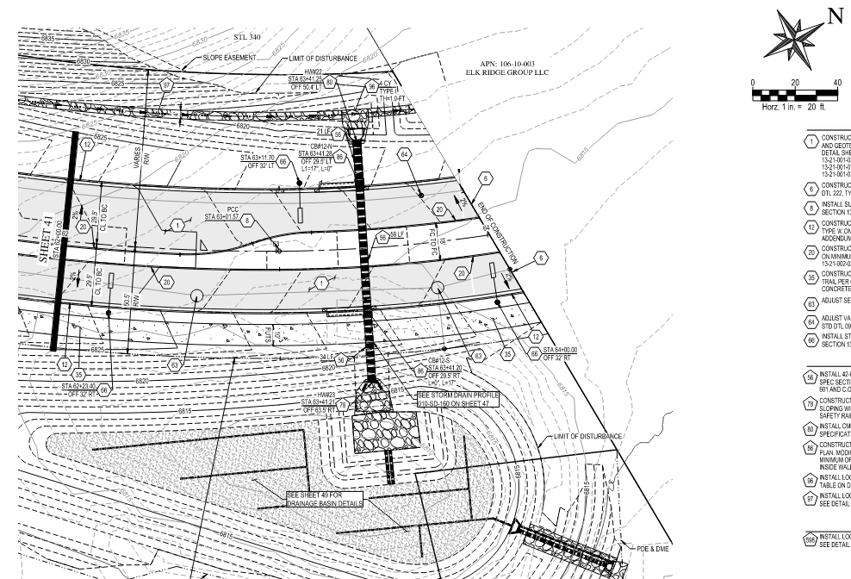
- 9 of 44: Adjust the streetlights at ~STA 221+17 & ~STA 223+25 (west side) a bit to the north to meet the spacing standard (200’ +10% = 220’ spacing max).
- 11 of 44: Can the streetlight at ~STA 236+40 (east side) be moved to the north near STA 236+90 while still meeting spacing standards?
- 11 of 44: Adjust the streetlights at ~STA 237+95 (west side) a bit to the south to meet the spacing standard (200’ +10% = 220’ spacing max).
- 12 of 44: The CDR plans show a streetlight on the east side near STA 247+00. Adjust the streetlight at ~STA 244+40 (east side) a bit to the north to meet the spacing standard (200’ +10% = 220’ spacing max).
- 12 of 44: The crest vertical curve near station 246+87 has a K value of 39, while COF standards state a minimum K value of 44.
- 12 of 44: STL405 plans end their construction with the signs shown below. This project does not need to post a speed limit sign on the west side. Please relocate it to the east side and include the No Parking Bike Lane (MUTCD R7-9a) with it.
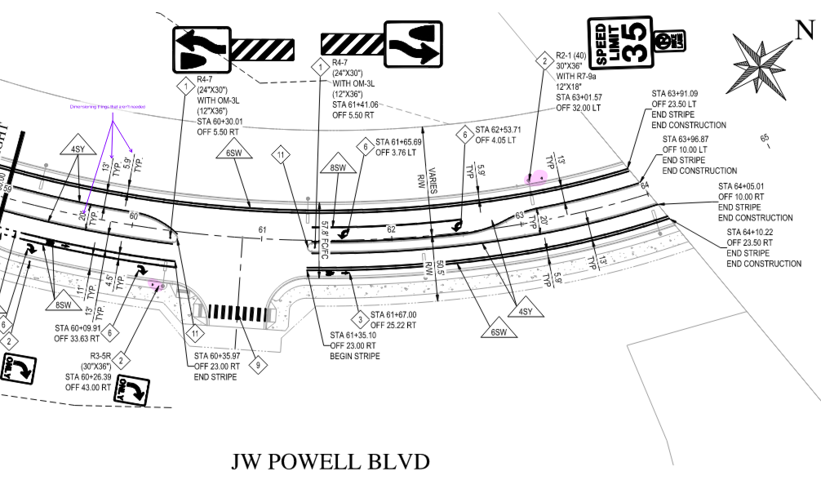
- 28 of 44: Near STA 215+00, west side, continue both broken white stripes for the 50'.
- 28-30 of 44: TYP – On each 35mph speed limit sign include a “No Parking Bike Lane” sign, MUTCD R7-9a. The two R7-9a’s signs and posts on sheet 30 of 44 can be removed once added to the speed limit signs posts.
- 28-30 of 44: TYP – Follow Eng Standard Detail 10-06-015 for median nose signs. This standard utilizes MUTCD OM3 versus the object marker shown on the plan view.
- 28-30 of 44: TYP – Note 610 – Refer to Eng Standard Detail 10-05-030 for sign post detail.
- 28-30 of 44: TYP – Include a construction note for the 6” broken white (1’ stripe w/ 3’ space), per Eng Standard Detail 16-06-010.
- 28-30 of 44: TYP – Note 630 – Include different notes for the various markings.
- 28-30 of 44: Include a sign and marking table. Provide MUTCD code, quantity, and size of signs.
- 30 of 44: Right turn lane signage shall follow Eng Standard Detail 10-10-020. The through/right lane designation shall be replaced with the right only sign.
- 30 of 44: Include the bike buffer through the right turn lane.
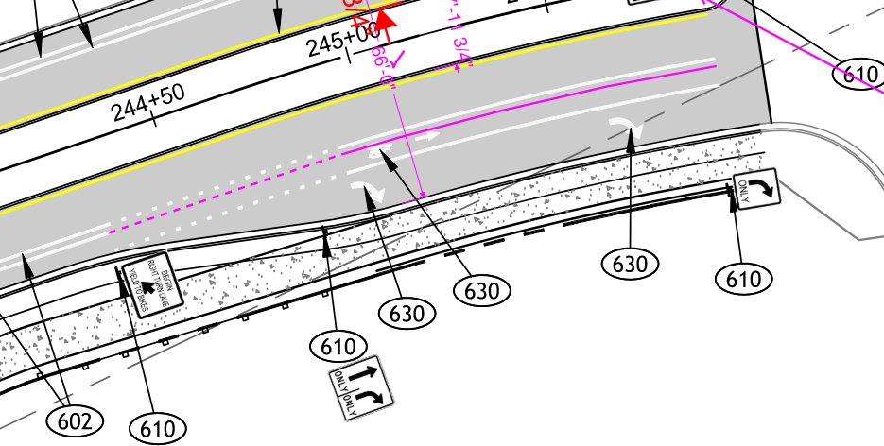
- 30 of 44: Include a NB left turn lane at Herold Ranch intersection. At Herold Ranch, the first image is the cross section of the north leg of the intersection and the second image is the south leg. The striping leaving this project will need to match into the proposed striping of CDR.
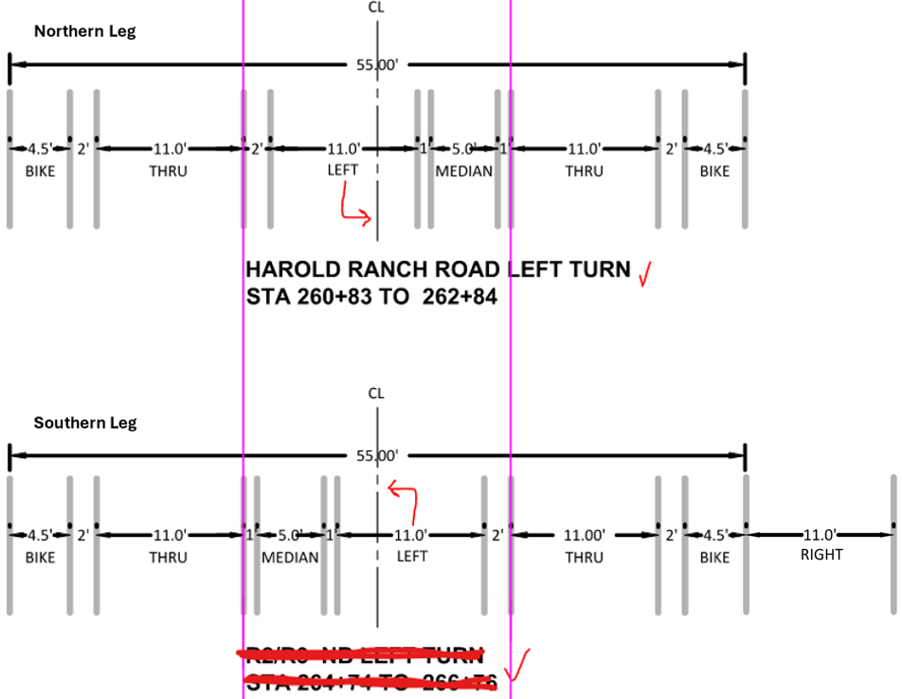

Transportation Planning:
- DT1.0. Match total height of modified FUTS rail to regular FUTS fence, 50”, the additional 2” should be added to the functional area, not just taller posts.
- DT1.1. Adjust direction of FUTS cross slope in Section 5 to avoid ponding and erosion.
- In many flatter areas, there is a lot of physical room to soften fill slopes for stability and to lessen the amount of FUTS fencing needed, provided a larger slope easement can be created. Note, this slope easement should not affect development of adjacent private property.
- Shift all FUTS-associated ramps to create less out of direction travel for FUTS users. These ramps shall also be 10’ wide. Adjacent JWP sections are using MAG 237 style ramps with a minimum distance from the curb return apex. Evaluate adjusting the limits of concrete behind ramps to create more direct paths of travel, not necessarily having to hold an offset to the curbs.
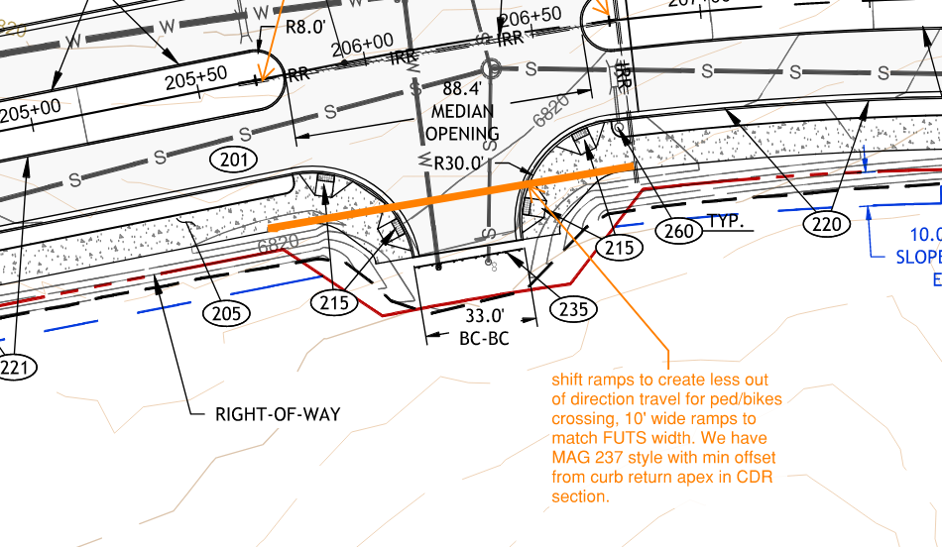
- R1.5. Grade the approach to Harold Ranch Road so that this intersection can have a signal or roundabout in the future.
- R1.5. Maintain the parkway near the intersection of Harold Ranch Road.

General Comments:
- Evaluate opportunities to expand the 5’ parkway. In many areas we essentially have 4’ of extra ROW beyond the FUTS shoulder that could be reallocated to the parkway with minor effects to any planned slope easements. 8’ of parkway should be the goal to allow for quality landscaping. This added width and accomplishing some grading in a larger parkway will also assist in signaling to users that this is its own, two-way, facility, not just a wide sidewalk. Example locations to expand the parkway include areas that don’t have much cut or fill to limit any cascading effects, and the area that leaves a sliver of undevelopable land.

Substantive Water Services: Water Services, Courtney Hawley Approved with Conditions 04/15/2026
Courtney Hawley 4/8/2026
Returned for Corrections
Conditions of Resubmittal
General
1. Please provide a master utility sheet. Provided.
2. Per engineering standard 13-09-003-0005, please ensure that inline valves are spaced a maximum of 800 feet and no more than 2 fire hydrants are placed between the span of 2 valves. Confirmed.
3. Please call out fitting types. Provided.
4. 13-09-003-005.B. only 2 hydrants shall be placed between valves. Confirmed.
W1.2
1. The valve is too deep and missing from the site plan. Waterline rerouted to avoid deep valve.
2. Please explain how 225+72.92 sewer will be installed and the water line will be protected. Waterline to be sleeved.
3. Note 303- please call out correct class for valve Corrected.
4. Note 1 - Bend is too close to curb. Please allow at least 4 feet of distance. Waterline rerouted.
5. Please ensure that there is a minimum of 6 feet distance between water and sewer. Extra protection called for where required.
W2.0
1. Please explain why the reclaim is going through the embankment instead of under the bridge. If this is necessary, please call out sleeves. Sleeve is called out on plans.
2. The maximum depth for a water line is 6ft. We recommend keeping it low to avoid SD crossing dips, additional ARVs and to provide proper cover for the valves. As discussed with Development Engineering and Water Services, okay to have deeper water main.
3. Please show water crossing in profile. Shown.
S1.0
1. Please use ductile pipe on the section of pipe with shallow cover Shown.
2. The sewer crossing the water main will require extra protection. Called out.
S2.0
1. Please call out 84” manhole instead of the junction structure. Manhole called out.

